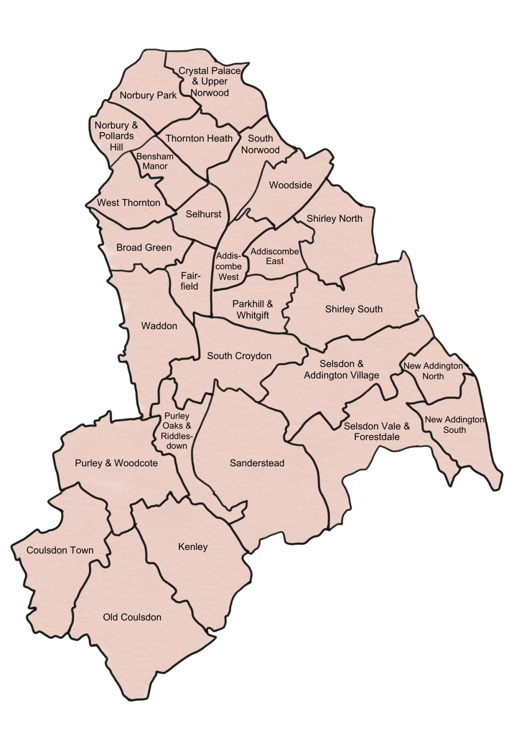

**Part 1 Application Form**

**Croydon Council Community Asset Transfer Scheme**

This part of the form asks for basic information about your organisation. It also asks about the building or land that you would like to manage

1. **NAME OF ASSET FOR WHICH A CAT LEASE IS SOUGHT:**

|  |
| --- |
|  |

1. **YOUR DETAILS:**

|  |
| --- |
| **Your group / organisation** |
| Full name of your group / organisation: |
| Address: |
| Telephone: |
| Post code: |
| Email address: |
| Website: |

|  |
| --- |
| **Main contact** |
| Full name: |
| Position: |
| Email address (if different from above): |
| Contact phone number (if different from above): |

1. **WHAT TYPE OF ORGANISATION / GROUP ARE YOU?**

|  |  |  |  |
| --- | --- | --- | --- |
| **Type** | **Please tick (√)** | **Type** | **Please tick (√)** |
| Partnership |  | Constituted Group |  |
| Company Limited by Guarantee |  | Newly formed group for asset transfer |  |
| Charity  (If a charity, please provide charity number) |  | Voluntary Organisation |  |
|  | Friendly Society |  |
| Community Benefit Society |  | Co-operative society |  |
| Community Interest Company |  | Unincorporated association |  |
| Unincorporated social enterprise |  | Other [please state] |  |

1. **WHAT YEAR WAS YOUR GROUP / ORGANISATION FORMED?**

|  |
| --- |
|  |

1. **WHAT SKILLS DOES YOUR GROUP / ORGANISATION HAVE?**

Please use the space below to share details of relevant skills such as, financial management, asset management, partnership working, fund raising, etc.

|  |
| --- |
|  |

1. **WHAT ARE YOUR PLANS FOR THE ASSET?**In addition to providing a brief summary in the box below, we recommend attaching a Business Plan with details such as activities, who will be responsible for managing the service, who will be responsible for maintenance and upkeep of the building or land, etc.   
     
   The Business Plan also needs to consider expenditure projections such as rent, rates, insurance, staff, security, maintenance etc. and income projections such as hiring out space, funding streams, grants, etc. We ask that you consider a 10 year timeframe for this financial forecast but accept that the detail after the first two years may be a little lighter.

It is also important to consider whether you are able to meet some of the costs that may be associated with the transfer. It is difficult to specify what these may be, as each transfer will be negotiated on an individual basis, however it may include feasibility study fees, architects fees, legal fees, Planning fees, etc.

|  |
| --- |
|  |

1. **HOW WILL THE COMMUNITY BENEFIT FROM THE PROPOSAL?**

Please use the space below to let us know how your proposal will benefit the community. For example, will your proposal maintain an existing service or activity in the local community, create a new service or activity in the local community, bring additional financial investment into the area, etc?

|  |
| --- |
|  |

1. **DOES YOUR PROPOSAL ACCORD WITH THE COUNCIL’S PROPOSED LEASE TERMS? (Please note: this question only needs to be answered if the Council has instigated the CAT proposal and has provided full marketing details).**

Use the space below to confirm you are happy to proceed on the basis of the proposed lease terms, or, if you are not, to let us know what terms you are seeking.

|  |
| --- |
|  |

1. **Data Protection Act**

|  |
| --- |
| We may use information on this form for purposes which are registered under the terms of the Data Protection Act 2018.  Occasionally, we receive requests from agencies that we work with, to pass on contact details of the organisations we support. We would normally only give out published office addresses, as this information is already in the public domain. If you do not want us to give out this information, please tick the following box.  I do **not** wish my organisation’s contact details to be passed on to any other agencies.  We do not pass on, sell, or otherwise give out this information to commercial organisations. |

1. **SIGNATURE**

|  |
| --- |
| **Name (print) (Sign)** |
| **Position in organisation:** |
| **Date:** |

**Please email your completed form to:** [estates.assets@croydon.gov.uk](mailto:estates.assets@croydon.gov.uk)

**Please note:** If your application is shortlisted (typically we will select the 3 highest scoring bids) you will be invited for an interview and may also, beforehand, be asked to provide answers to supplementary questions arising from your Part 1 Application Form.   
  
The council reserves the right to shortlist less than 3 applicants, or not shortlist any applicants, if it considers that the quality of the bids received is too low.