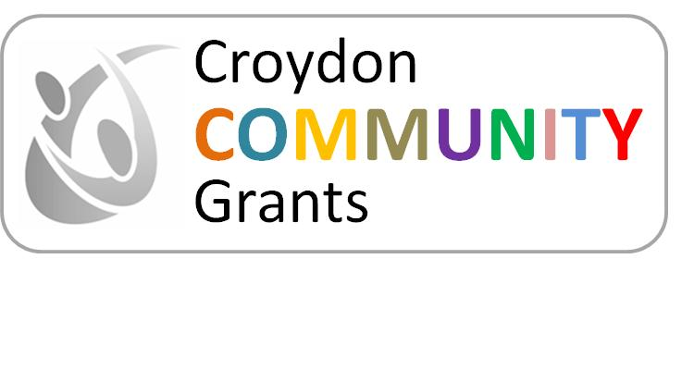
Common Ground
Resilience Fund

Croydon’s V

Croydon Common Ground Resilience Fund (CGRF) Grant Application Form

Croydon Council is inviting applications for grants of up to £4,500 for activities on and around Holocaust Memorial Day in January 2026 that meet one or both of the following
• Reduce divisions and build resilience in places facing cohesion challenges and heightened risk of community tensions.
• Support local people and organisations to build ‘bridging social capital’ in their communities, by investing in shared spaces and activities which bring people from different backgrounds together.

More information on the Holocaust Memorial Day 2026 theme of Bridging Generations is available here Holocaust Memorial Day Trust | Bridging Generations: Theme for 2026

Grant Amount: Up to £4,500 per project
Total Available: £22,500
Funding Period: Activities must take place no later than 28th Feb 2026.
Funds must be awarded by: 31 Mar 2025
Deadline: Friday 5th December 2025 (to be sent to communityrelations@croydon.gov.uk)

Section 1. Organisation Details
Organisation name
Organisation address
What type of organisation are you? Registered charity number if applicable
Contact name
Job title/ Position
Contact telephone number
Contact email address
Contact address (if different to above)

Section 2: Project Details
Project name/title
Brief description of activity (max 250 word)
Project start date
Project end date
Where will your project activities take place (include postcode or area name)
Section 3: How your Project/ Activities Meets the Fund Objectives
Please explain how your project/activities will meet one or both of the following objectives (max 300 words)

- Reduce divisions and build resilience in places facing cohesion challenges and heightened risk of community tensions

- Support local people and organisations to build “bridging social capital” in their communities, by investing in shared spaces and activities which bring people from different backgrounds together.
Section 4: Budget
Total Amount Requested (up to £4,500)
Breakdown of cost or attach income & expenditure
Venue Hire
Materials
Staffing
Other (please specify)
Provide a brief project budget outlining all project income and expenditure and how you expect to spend the requested amount. Alternatively attach as a separate spreadsheet. | Project Income | Expenditure Items
Section 5: Impact and Outcomes
Expected Outcomes (max 250 words)
Describe the need for your funding request and how it will make a positive impact on your community.
How will you measure success?
Section 6: Safeguarding & Compliance
Do you have appropriate safeguarding policies in place – please attach | Yes / No
Insurance Cover if applicable | Yes / No
Any other compliance requirements
Section 7: Declaration
I confirm that the information provided is accurate and that the organisation will comply with all funding conditions.

Name: ________________________________________

Date: ________________________________________

Signature: ________________________________________

All completed applications forms should be emailed to communityrelations@croydon.gov.uk

