Application for Neighbourhood Forum Status
1. What is the name of the proposed Neighbourhood Forum?
2. What is the name of the proposed Neighbourhood Area to which the application relates?
3. Contact Details (will be made publicly available)
Name:
Address:
Email:
Telephone:

4. Who are the proposed members and what is their interest? (please note a minimum of 21 members is required)
Name | Must be local to Neighbourhood Area  (please tick as appropriate) |  |  | Other  (please explain)
Name | Resident | Business owner  or Worker | Councillor | Other  (please explain)
5. Please provide a map (OS based at an appropriate scale) which clearly identifies the Neighbourhood Area. If the Neighbourhood Area does not align with the Core Strategy 16 Places (see figure 1), the Council will require justification regarding why it is not possible or desirable to define the Neighbourhood Area in these terms.
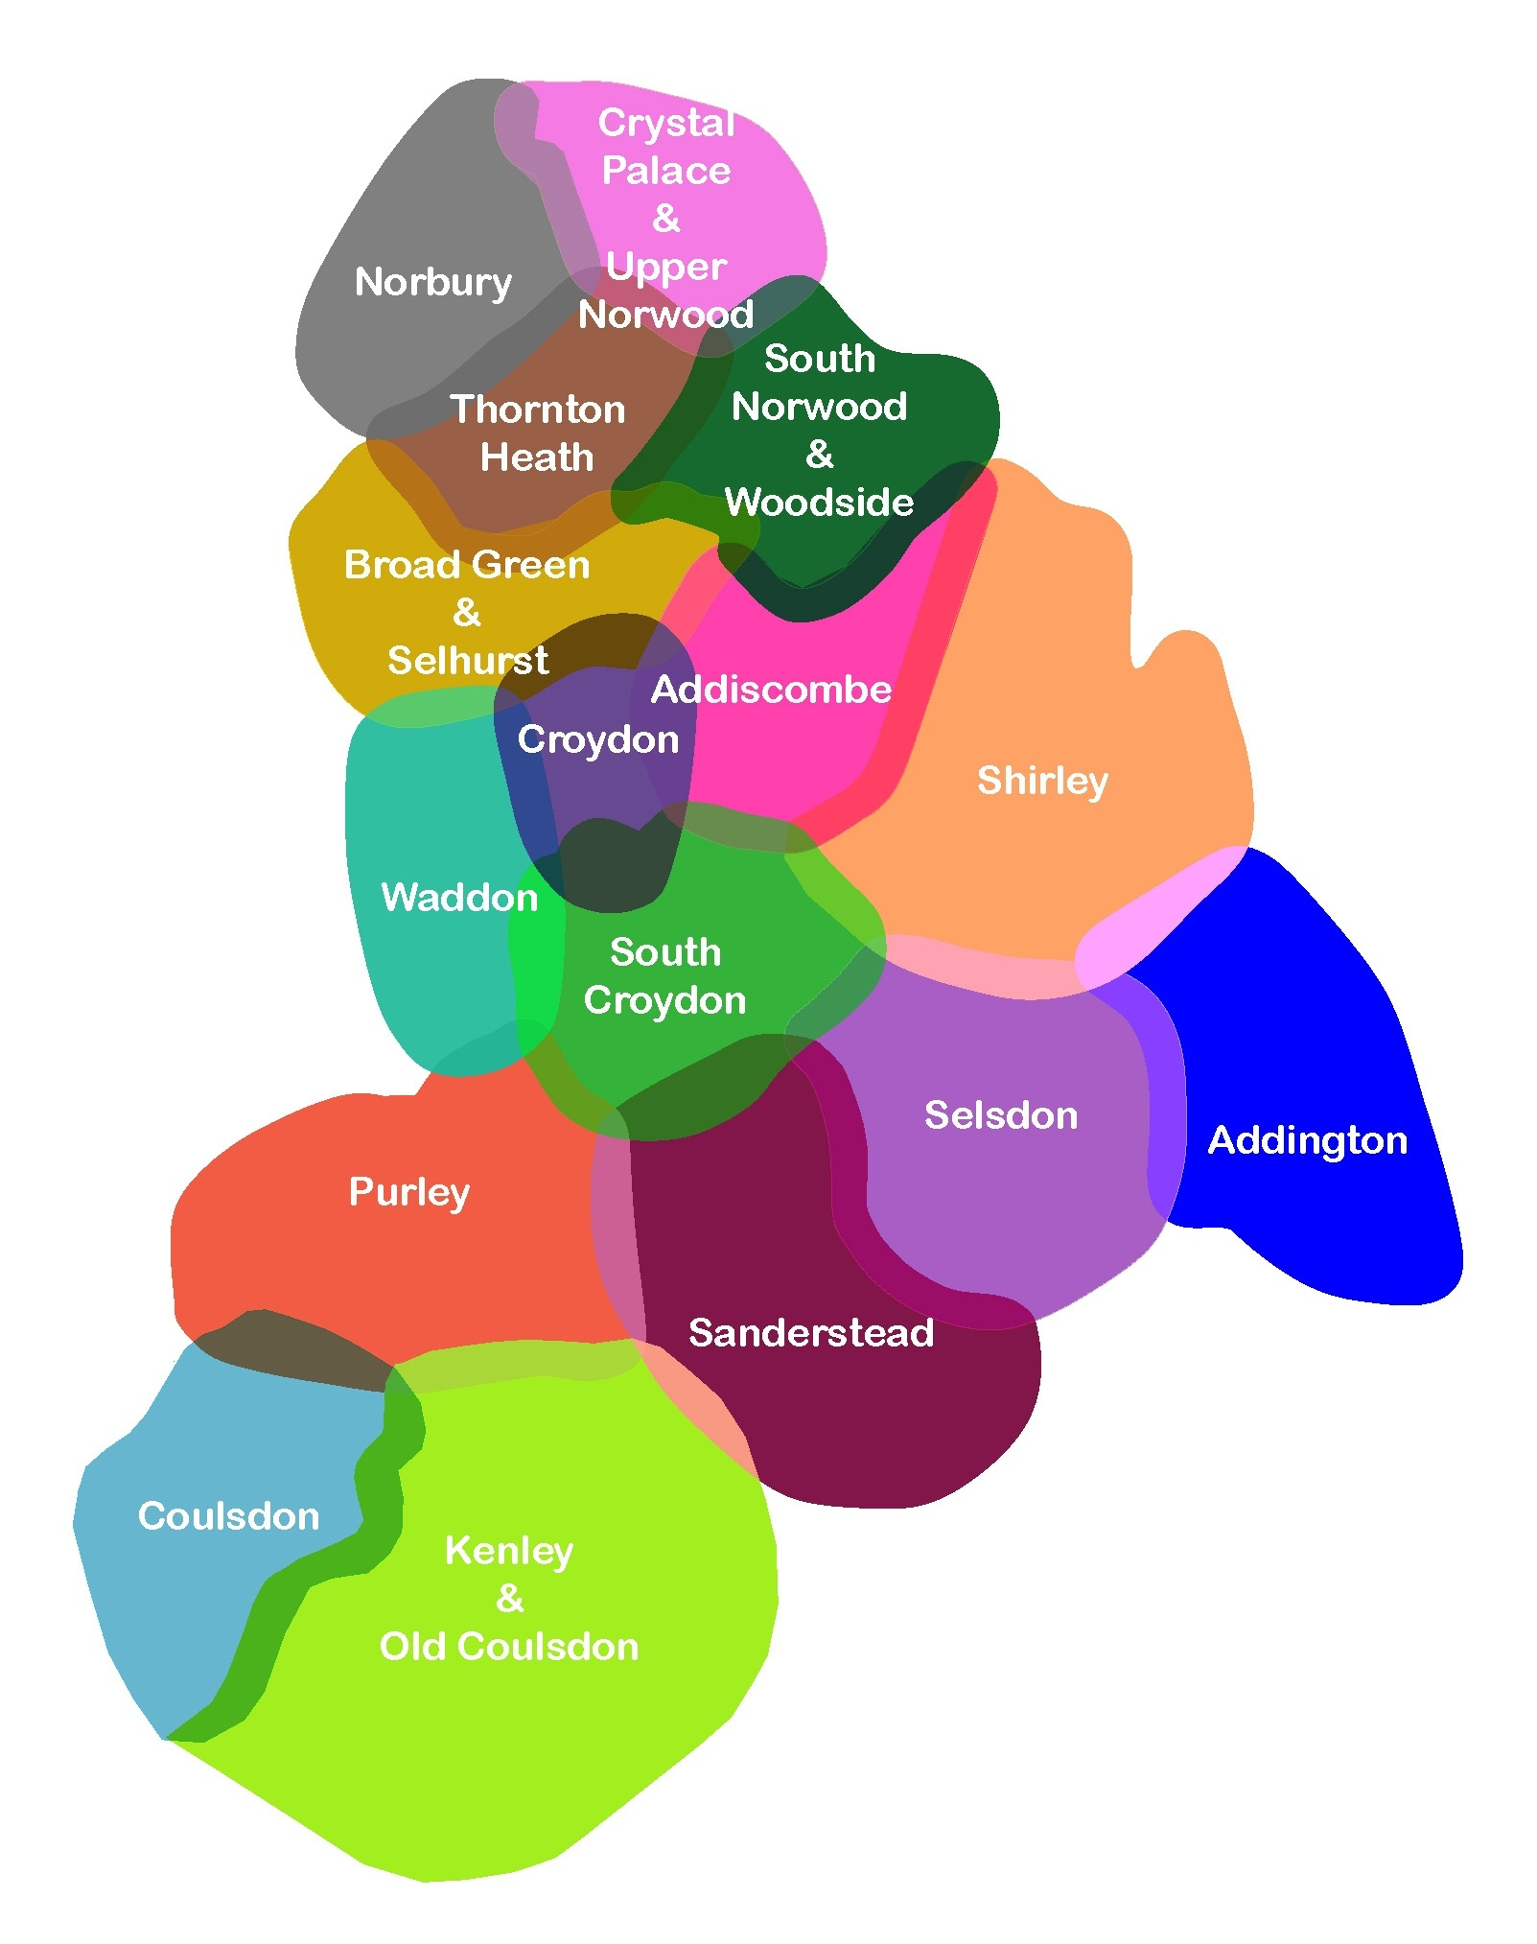
Figure 1 The Core Strategy 16 Places of Croydon

Please also include the following supporting information;
- A copy of the written constitution of the proposed Neighbourhood Forum.
- A statement which explains how the proposed Neighbourhood Forum meets the conditions contained in section 61F(5), Schedule 9 of the Town and Country Planning Act 1990.
- If your neighbourhood area covers land outside of Croydon please provide a map that indicates the relevant area(s) and details of the relevant representative(s) that you have contacted.
- If available, a financial balance sheet for the last financial year for the Neighbourhood Forum.
- A brief statement setting out the main intention for establishing the Neighbourhood Forum, for example Neighbourhood Development Plan.

/tmp/in/input.doc

